DERIVATION
Terms:
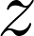, a dichotomous random variable that alternates over time between two states

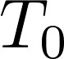, random duration of state 0, with density function 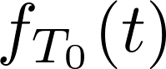
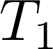, random duration of state 1, with density function 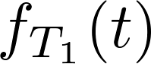
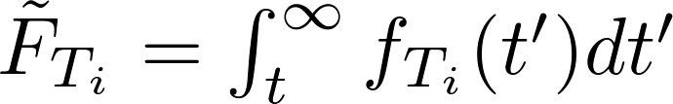, the complementary cumulative distribution function for durations
, random elapsed time since entering state
, the hazard function. 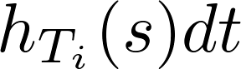 gives the probability of exiting state in time interval 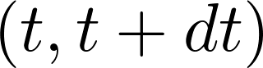, given that 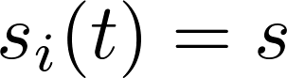.
, Fourier transform of a function 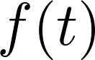
...
For each of the two alternating states z = {0,1}, the rate of change in probability per unit time depends on the evolution of the s variable, the time since entering the current state as well as the possible switch into the other state. As ds/dt = 1, the flux of probability is simply f(x). .
(1)
(2)
The value of s is reset to 0 whenever an alternation between states occurs. The initial probability source at s = 0 is determined by the probability of switches out of the previous state, leading to the following boundary conditions:
(3)
(4)
Initial Conditions:
(5)
We first solve for the case of starting in state 1.
…
Using these conditions, a solution can be found for :
(6)
…
To find the probability 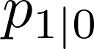, simply time shift the above expression by the durations of the initial state, , whose density function is 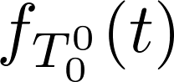-- the switch times are then described by 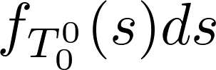. This amounts to a convolution of the density for initial durations with the previous solution:
(7)
Thus the solution can be given in the Fourier domain as:
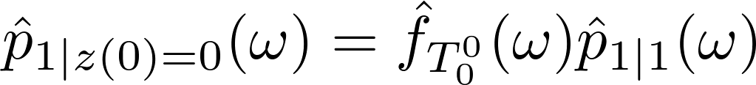. (8)
Using the simplifying assumption that 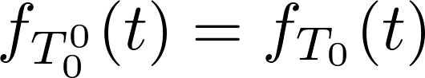, eg the first duration is from the same probability density as all other , we find that:
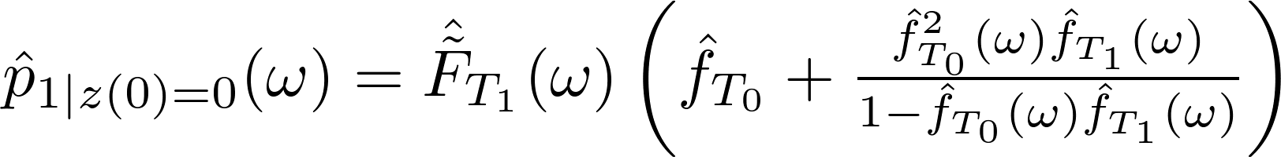 (9)

(Finishing up: at omega = 0, f_hat(omega) = mu_T1/(mu_T1 + muT0); ifft, integrate from 0 to t.)

